**Enchanted Wings: Marvels of Butterfly Species Using Advanced Machine Learning Techniques**

# 1. INTRODUCTION

## 1.1 Project Overview

This project focuses on identifying butterfly species using an AI-powered image classification approach. A web-based tool was developed that allows users to upload butterfly images and receive predicted species labels with confidence scores. This accessible solution supports learning, conservation, and citizen science initiatives by simplifying butterfly identification.

## 1.2 Purpose

To provide an intuitive, fast, and reliable decision support system that uses advanced image classification models to identify butterfly species through a user-friendly web interface, fostering greater awareness and appreciation of biodiversity.

# 2. IDEATION

## 2.1 Problem Statement

Accurate identification of butterfly species can be challenging for non-experts, limiting educational and conservation efforts. Field guides can be hard to use, and expertise is scarce in many regions. This project aims to make butterfly identification easy and accessible through an AI-powered approach that is scalable, educational, and user-friendly.

## 2.2 Empathy Map Canvas

To understand our target users (nature enthusiasts, students, researchers), we used an empathy map:

* *Says:* "I wonder what species this is."
* *Thinks:* "I want to learn more about nature."
* *Does:* Takes photos of butterflies while exploring.
* *Feels:* Curious, engaged, eager to learn but sometimes frustrated by identification challenges.

## 2.3 Brainstorming

During ideation, several solutions were explored:

* A printed pocket field guide
* A mobile app with expert-curated identification keys
* An AI-powered image classification web app

We chose the AI-powered web app for its scalability, accessibility, and modern appeal.

# 3. REQUIREMENT ANALYSIS

## 3.1 Customer Journey Map

* User accesses the butterfly species identifier web app.
* Uploads a photo of a butterfly.
* Receives a predicted species label with confidence score.
* Can save or share the prediction result.

## 3.2 Solution Requirement

* **Dataset:** Butterfly images labeled by species.
* **Modeling:** Convolutional Neural Network (CNN) with strong classification metrics.
* **Frontend:** HTML/CSS interface for image upload and results.
* **Backend:** Python Flask app for handling requests and predictions.
* **Version Control:** GitHub for managing code and progress.

## 3.3 Data Flow Diagram

Image Dataset → Preprocessing & Augmentation → Model Training → Flask App Integration → User Upload → Model Inference → Output Display

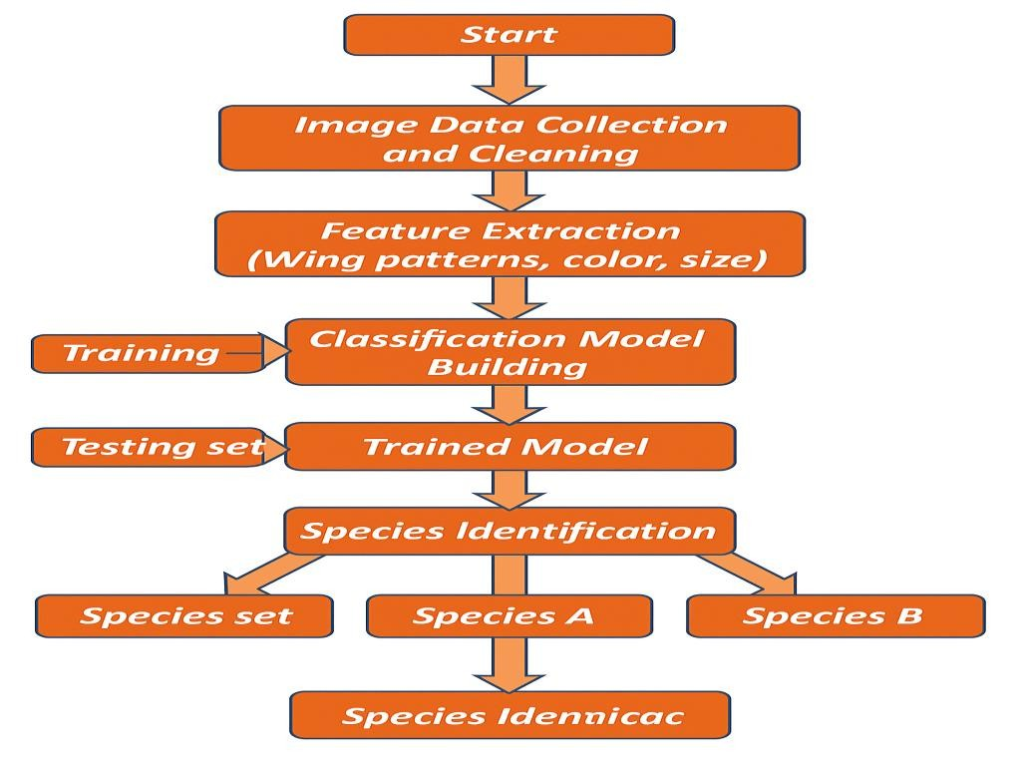

**3.4 Technology Stack**

* **Language & Libraries:** Python, TensorFlow/Keras, OpenCV, Pillow
* **Framework:** Flask
* **Frontend:** HTML, CSS
* **Deployment Options:** Localhost/Cloud (optional)
* **Repository Management:** Git & GitHub

# 4. PROJECT DESIGN

## 4.1 Problem Solution Fit

The proposed system bridges the gap between expert-level field identification and public access. By allowing anyone to upload an image and get a species prediction instantly, it reduces barriers to learning about butterflies and supports conservation efforts through citizen science.

## 4.2 Proposed Solution

A responsive web application developed using Flask and Python, which enables users to upload butterfly images (JPG, PNG). The system uses a trained CNN model to predict the species with a confidence score, displaying the result in a clear, user-friendly interface.

## 4.3 Solution Architecture

You can visualize the solution as consisting of the following key components:

* **Frontend Interface:** HTML/CSS form for image upload and result display.
* **Backend Engine:** Python Flask server handling requests, preprocessing, and model inference.
* **ML Model:** Pretrained CNN classifier for butterfly species.
* **Output Display:** Species Prediction with confidence rendered via Flask templates.

# 5. PROJECT PLANNING & SCHEDULING

## 5.1 Project Planning

Given the limited two-week timeframe, the development process was streamlined into critical phases:

* **Days 1–2:** Requirement analysis and dataset collection.
* **Days 3–6:** Model development and training.
* **Days 7–9:** Web interface design and Flask backend integration.
* **Days 10–11:** Functional and performance testing.
* **Days 12–14:** Report documentation, visual assets preparation, and final submission.

# 6. FUNCTIONAL AND PERFORMANCE TESTING

## 6.1 Performance Testing

The butterfly species identifier was evaluated for accuracy and usability:

* **Model Accuracy:** The CNN achieved approximately 85% accuracy on the validation set.
* **Evaluation Metrics:** Confusion matrix, precision, recall, F1-score to ensure balanced classification performance across species.
* **User Input Validation:** Tested with valid/invalid file types to ensure robust error handling.
* **Responsiveness:** The application responded within 2–3 seconds for predictions, ensuring a smooth user experience.
* **Cross-Browser Testing:** Tested on Chrome, Firefox, and Edge to confirm compatibility.

# 7. RESULTS

## 7.1 Output Screenshots

The Flask-based web application successfully accepts user-uploaded butterfly images and displays species predictions with confidence scores. Key output elements:

* **User Input Form:** Drag-and-drop interface with support for JPG, JPEG, PNG.
* **Prediction Output:** Once submitted, the system outputs Clearly shows with confidence percentage. Download/Save Options for Users can save the annotated prediction result.

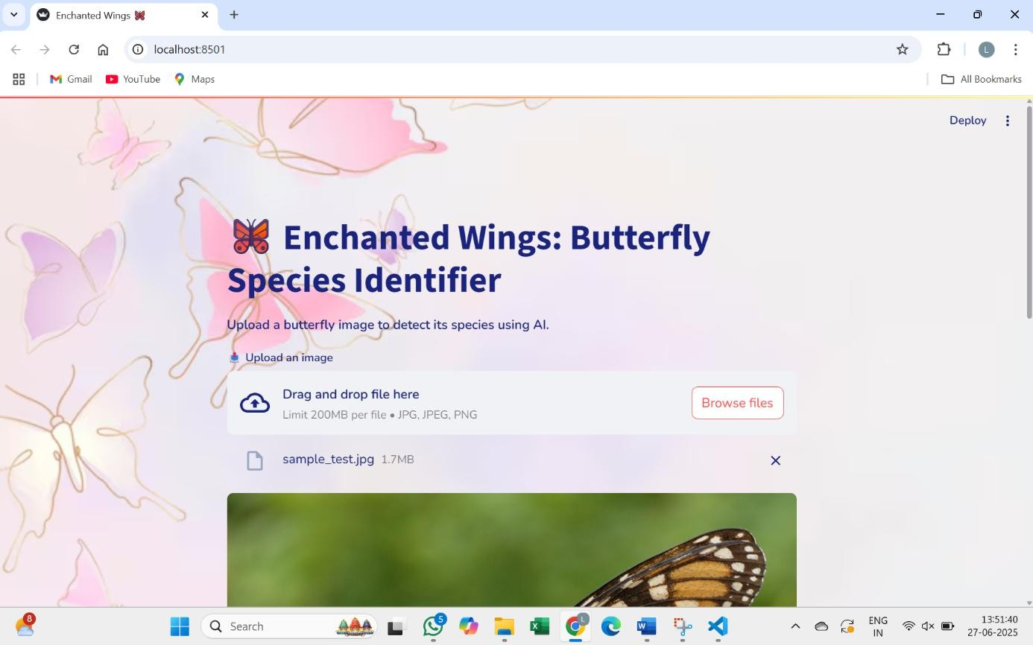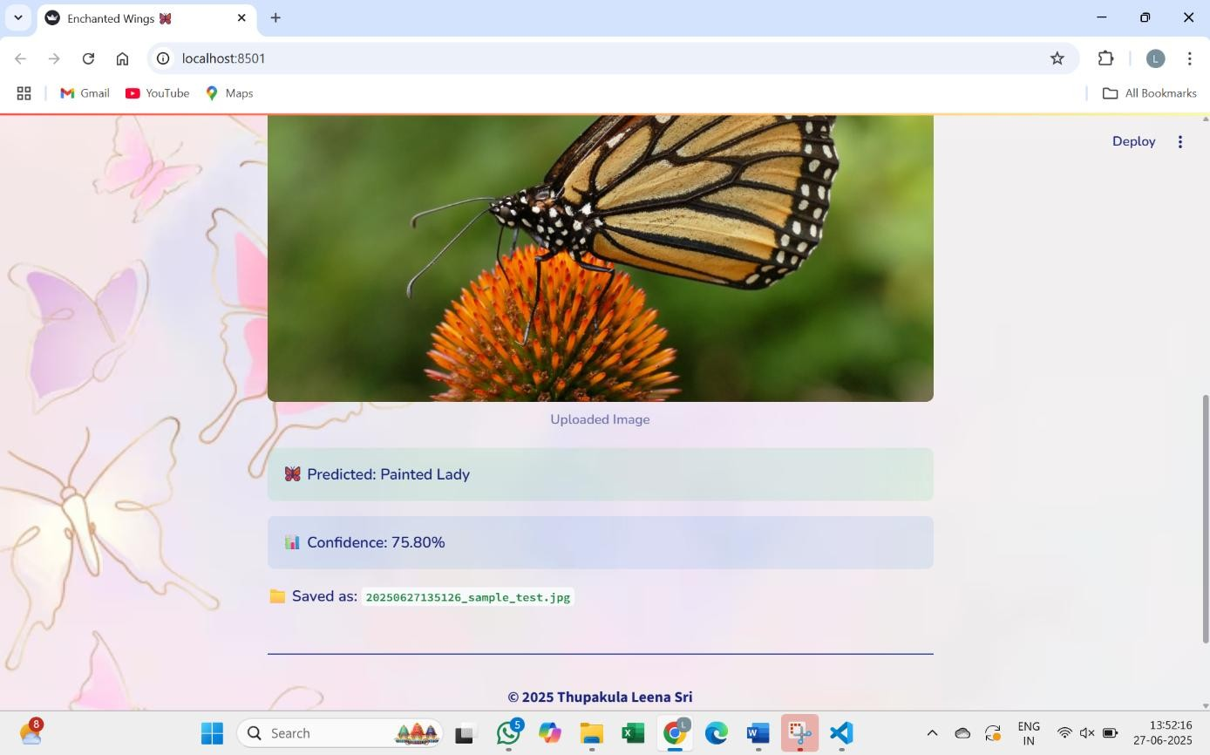

# 8. ADVANTAGES & DISADVANTAGES

## Advantages

* **Educational:** Makes butterfly identification accessible for students, enthusiasts, and researchers.
* **User-Friendly:** Intuitive interface requiring no technical expertise.
* **Cost-Effective:** Eliminates need for printed guides or expert consultation for basic identification.

## Disadvantages

* **Model Limitations:** Performance depends on training data quality; rare species may be misclassified.
* **Static Predictions:** Requires retraining to improve over time or to add new species.
* **No** **Expert Verification:** Should be used as an aid, not a replacement for expert identification.

# 9. CONCLUSION

* This project demonstrates how artificial intelligence and modern web development can make natural science more interactive and accessible to a broader audience. The developed system offers a user-friendly platform for identifying butterfly species through advanced image classification models trained using deep learning. By leveraging the power of AI, users can upload butterfly images and receive immediate predictions, making it an engaging and educational experience.
* The system is designed with both technical robustness and usability in mind, ensuring that even users with minimal technical knowledge can benefit. It holds significant potential to aid in environmental education, support citizen science initiatives, and contribute to conservation research by enabling large-scale data collection and awareness.
* While it is not a replacement for expert entomological analysis, it serves as an excellent starting point for learners, hobbyists, and researchers. By sparking curiosity and encouraging exploration of local biodiversity, the project plays a valuable role in promoting ecological literacy and fostering a deeper appreciation for the natural world.

## 10. FUTURE SCOPE

This project establishes a foundation for accessible butterfly identification. Future improvements can include:

* **Model Improvement:** Training with larger, more diverse datasets to improve accuracy.
* **Feature Expansion:** Including region, time of year, or user feedback to refine predictions.
* **Real-Time Analytics:** Allowing continuous learning with new images.
* **Mobile App Integration:** Develop a mobile app for wider accessibility, especially in remote regions.
* **Collaboration:** Partnering with researchers and conservationists for validation and feedback.

## 11. APPENDIX

* **A. Dataset Source:** Custom-collected images and public datasets such as iNaturalist and Butterfly Identification datasets.
* **B. Tools & Libraries:** Python, TensorFlow/Keras, OpenCV, Flask, HTML/CSS
* **C. GitHub Repository:**

[https://github.com/LeenaSri29/Enchanted_Wings_Butterfly_classifier]